Contents

FA-1f 2

**P=0.5, initial = 0** “data_fa1f_q(0.5)_ini(0)” 2

P = 0.1, initial = 0 data_fa1f_q(0.1)_ini(0) 3

**P=0.3, initial=0**, “data_fa1f_q(0.7)_ini(0)” 5

**P=0.4, initial=0**, “data_fa1f_q(0.6)_ini(0)” 5

P=0.5, initial =0.495, “data_fa1f_q(0.5)_ini(0.495)” 6

P=0.9, initial =0.85, “data_fa1f_q(0.1)_ini(0.85)” 8

P=0.8, initial =0.75, “data_fa1f_q(0.2)_ini(0.75)” 11

EAST 13

**P=0.5, initial = 0** “data_east_q(0.5)_ini(0)” 13

P = 0.5, initial = 0.49 “data_east_q(0.5)_ini(0.49)” 15

**P=0.1, initial=0**, “data_east_q(0.9)_ini(0)” 17

**P=0.8, initial=0**, “data_east_q(0.2)_ini(0)” 19

**P=0.9, initial=0**, “data_east_q(0.1)_ini(0)” 20

**P=0.9, initial=0.85**, “data_east_q(0.1)_ini(0.85)” 21

**P=0.8, initial=0.75**, “data_east_q(0.2)_ini(0.75)” 24

**P=0.7, initial=0.65**, “data_east_q(0.3)_ini(0.65)” 27

**P=0.6, initial=0.55**, “data_east_q(0.4)_ini(0.55)” 30

Addictive Model 31

P = 0.5, initial = 0 data_addictive_q(0.5)_ini(0) 31

**p=0.7, initial=0.65**, “data_addictive_q(0.3)_ini(0.65)” 33

**p=0.8, initial=0.75**, “data_addictive_q(0.2)_ini(0.75)” 36

**P=0.9, initial=0.85**, “data_addictive_q(0.1)_ini(0.85)” 39

Starting with initial density = 1 42

**L=5000** 42

# FA-1f

### **P=0.5, initial = 0** “data_fa1f_q(0.5)_ini(0)”

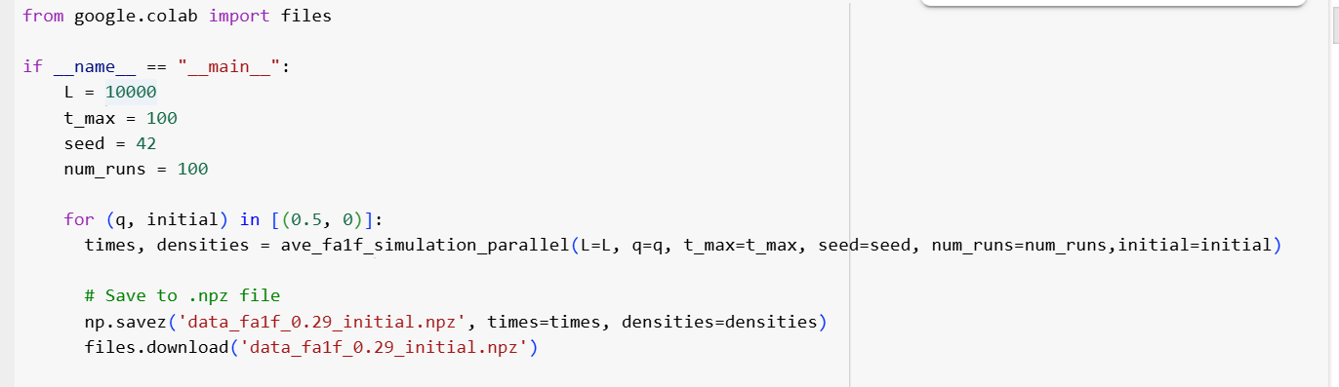

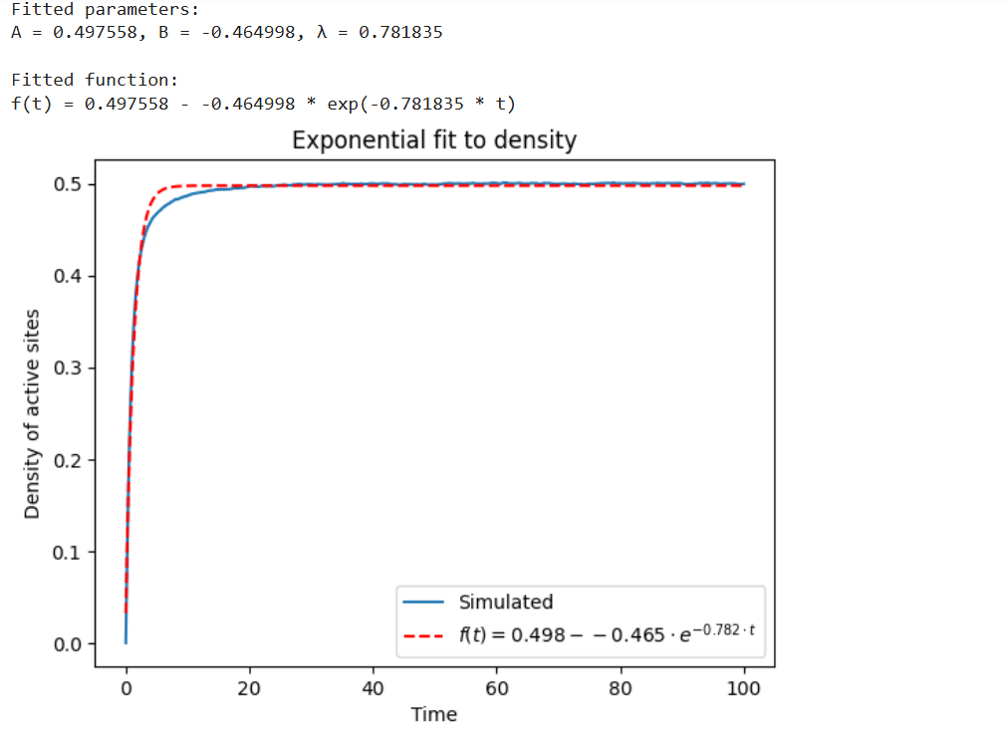

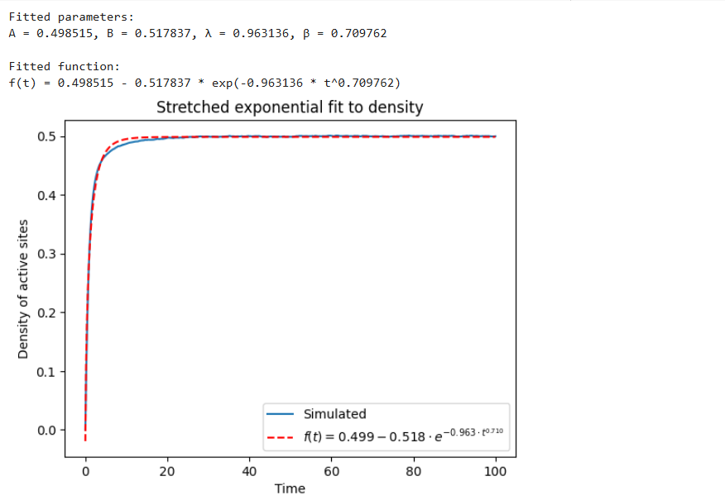

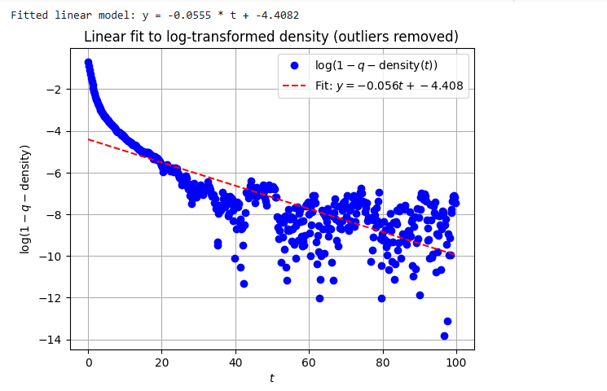

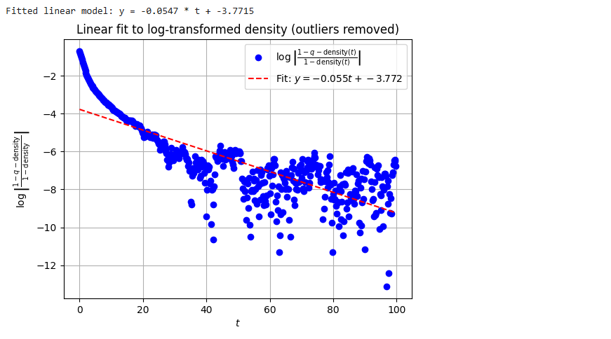

### P = 0.1, initial = 0 data_fa1f_q(0.1)_ini(0)

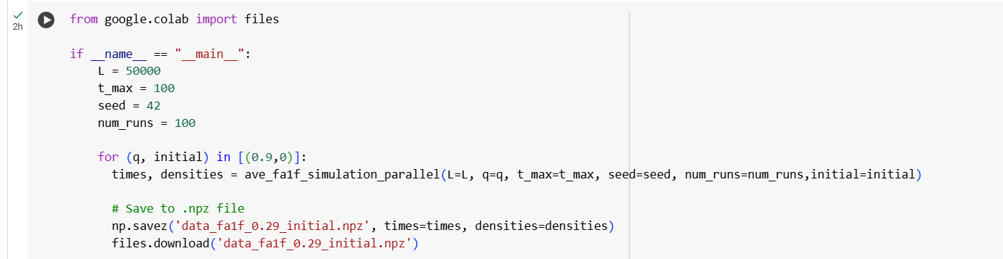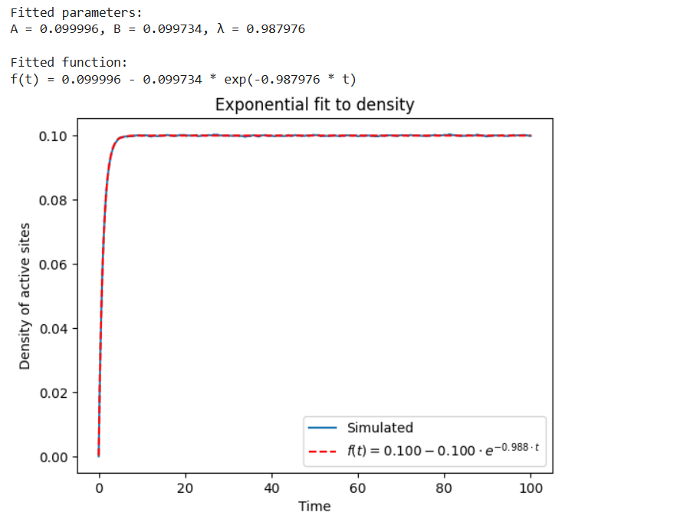

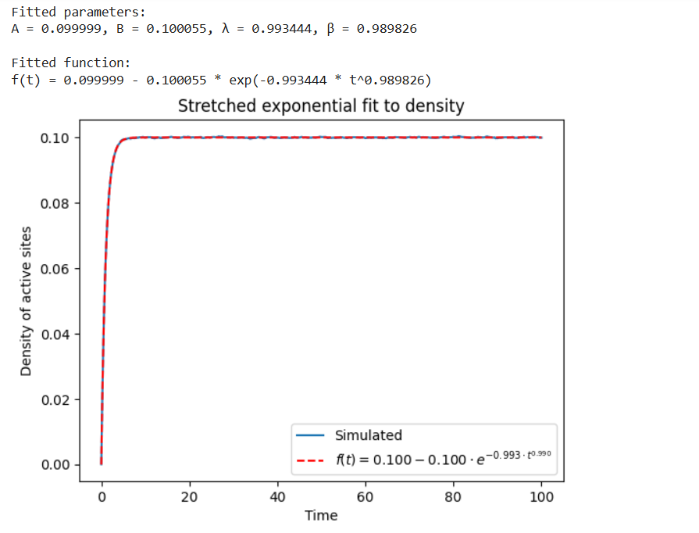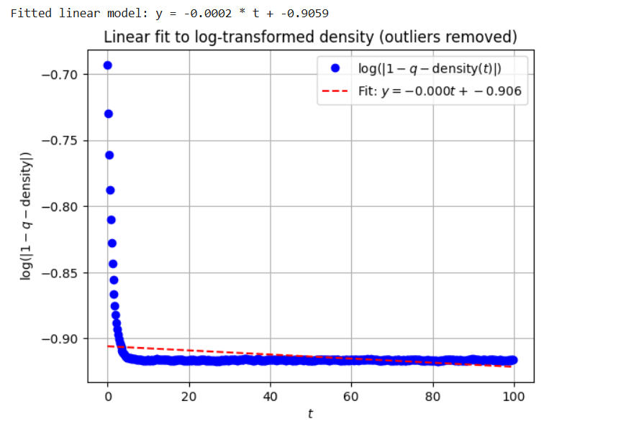

**P=0.3, initial=0**, “data_fa1f_q(0.7)_ini(0)”

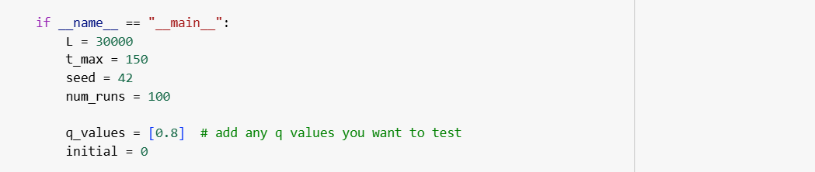

**P=0.4, initial=0**, “data_fa1f_q(0.6)_ini(0)”

 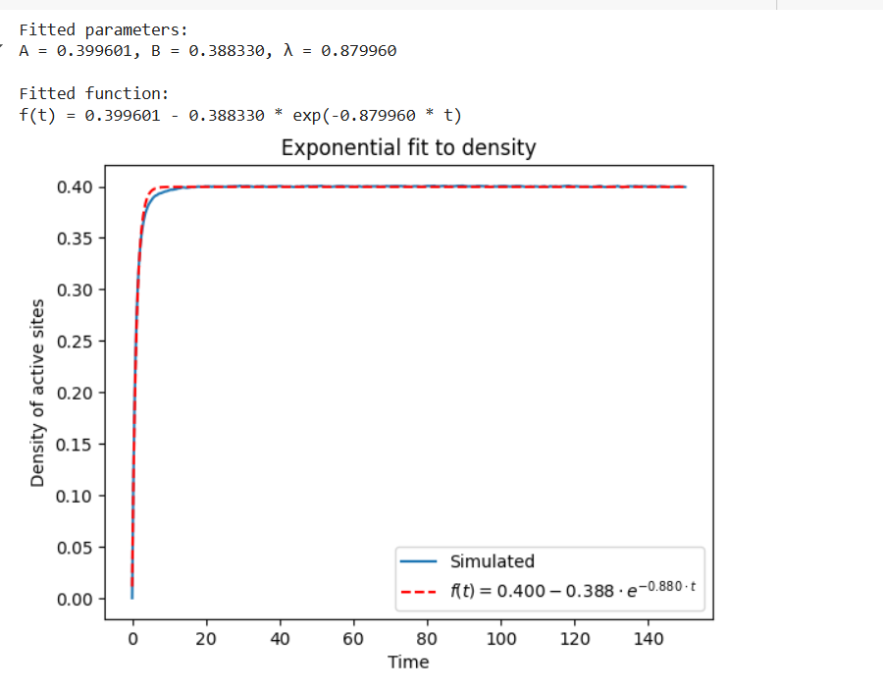

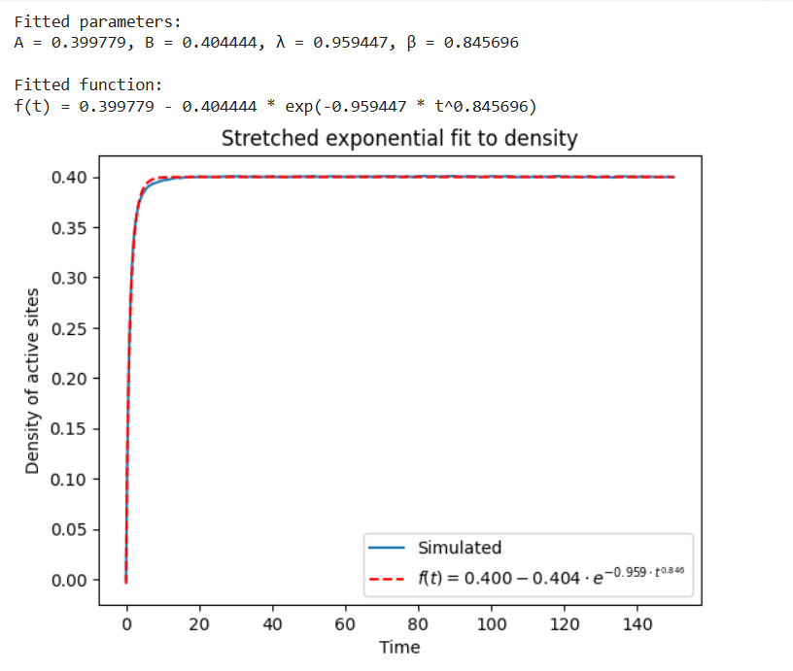

### P=0.5, initial =0.495, “data_fa1f_q(0.5)_ini(0.495)”

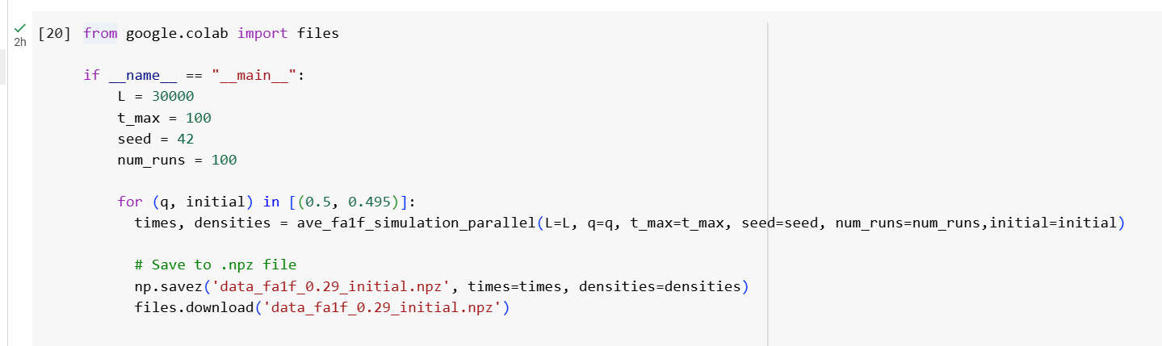 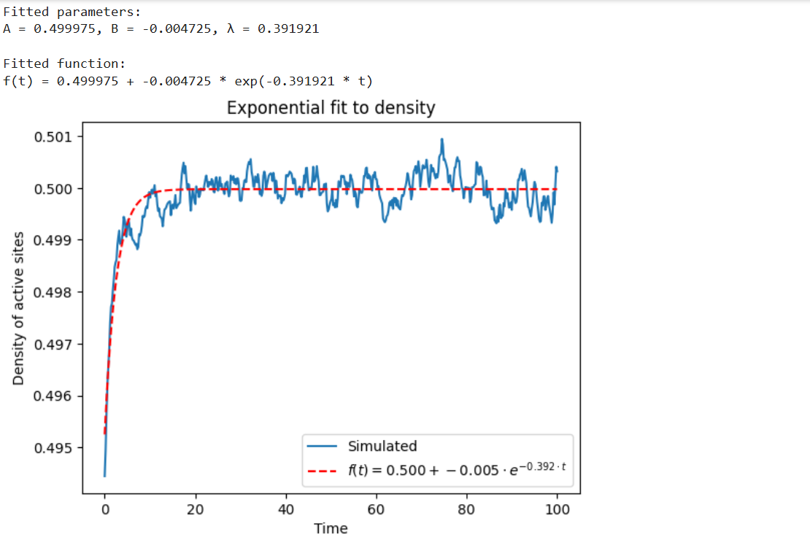

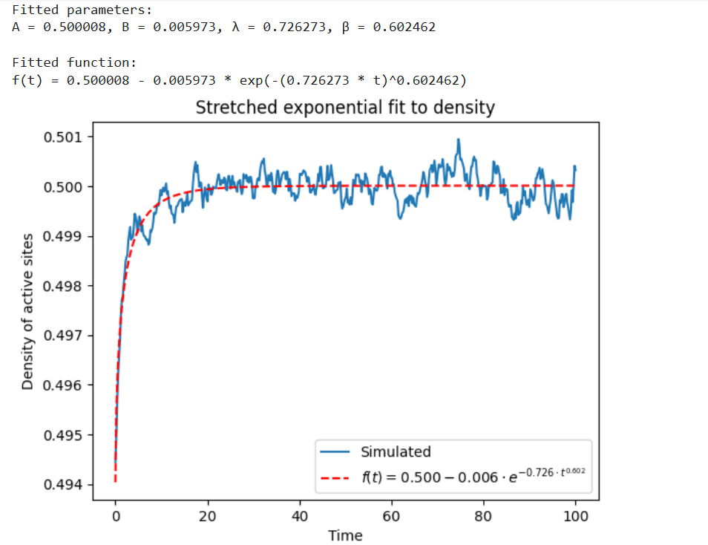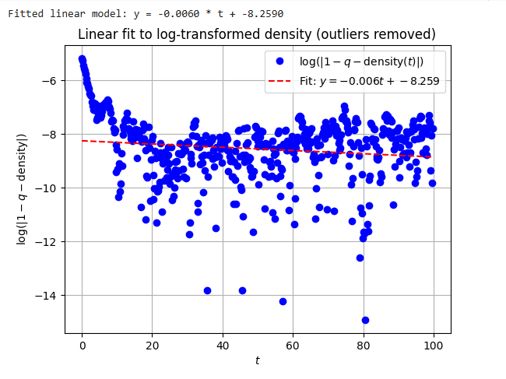

P=0.9, initial =0.85, “data_fa1f_q(0.1)_ini(0.85)”

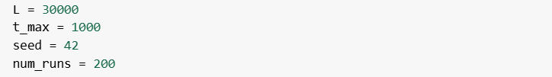

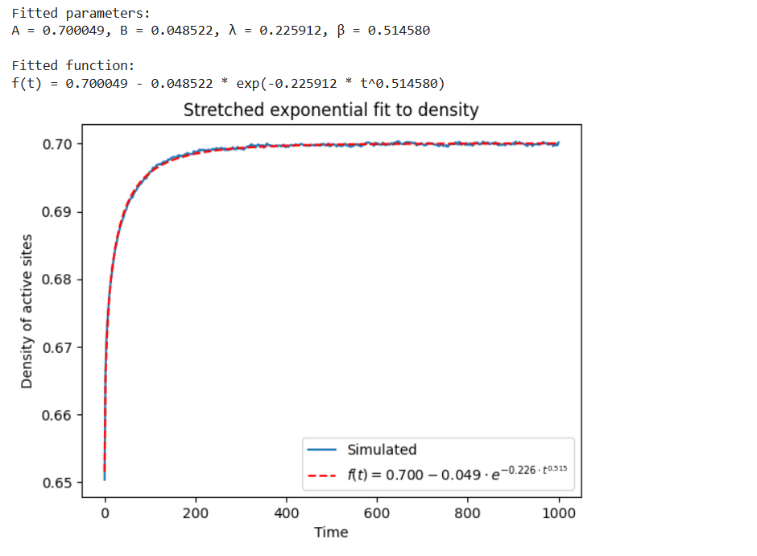 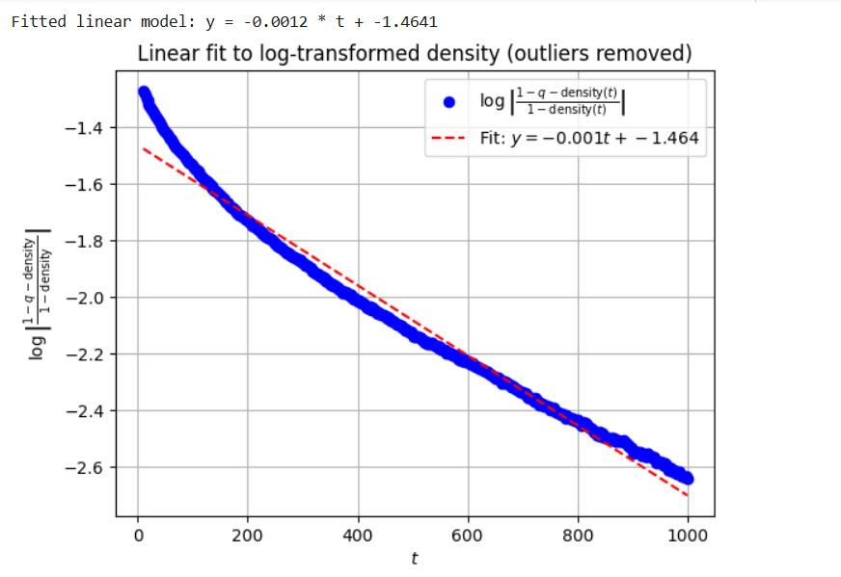 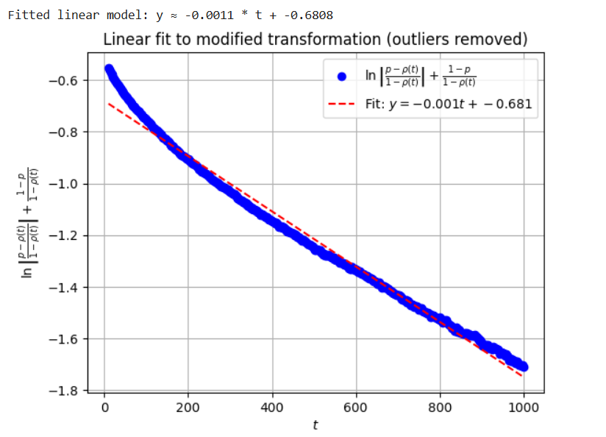 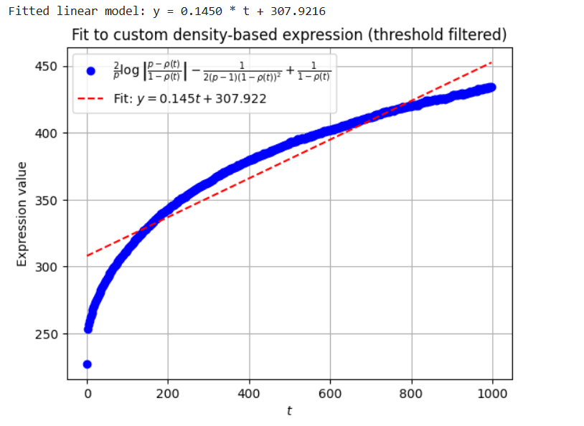

P=0.8, initial =0.75, “data_fa1f_q(0.2)_ini(0.75)”



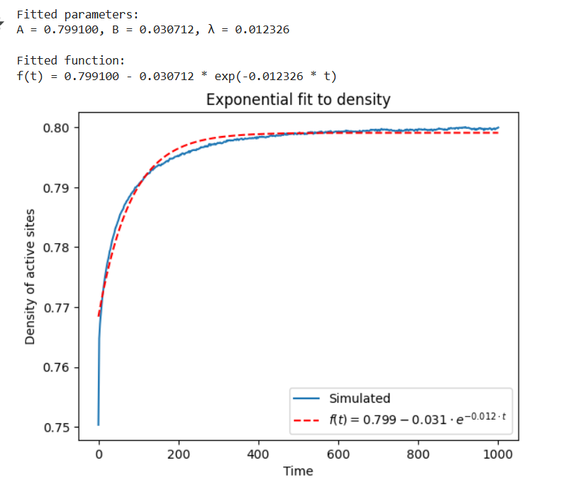

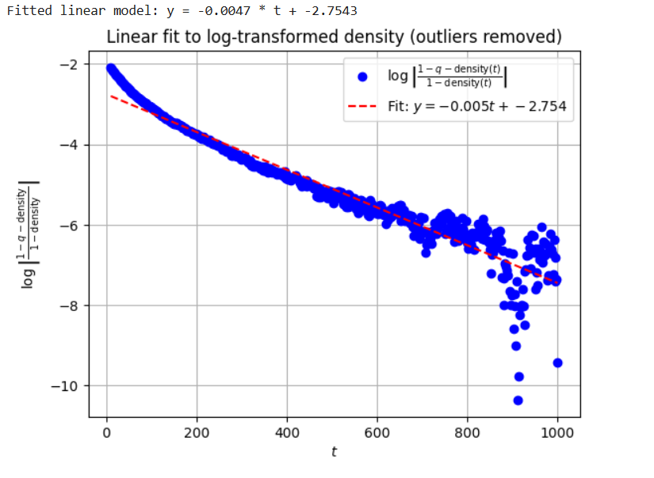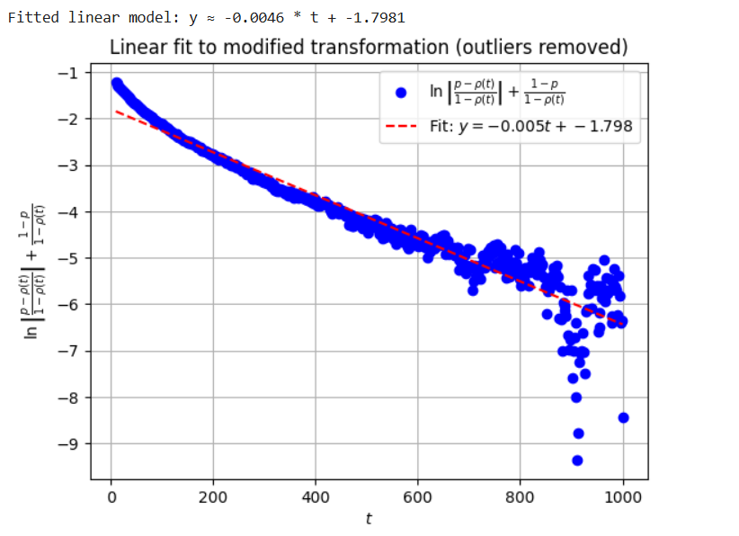

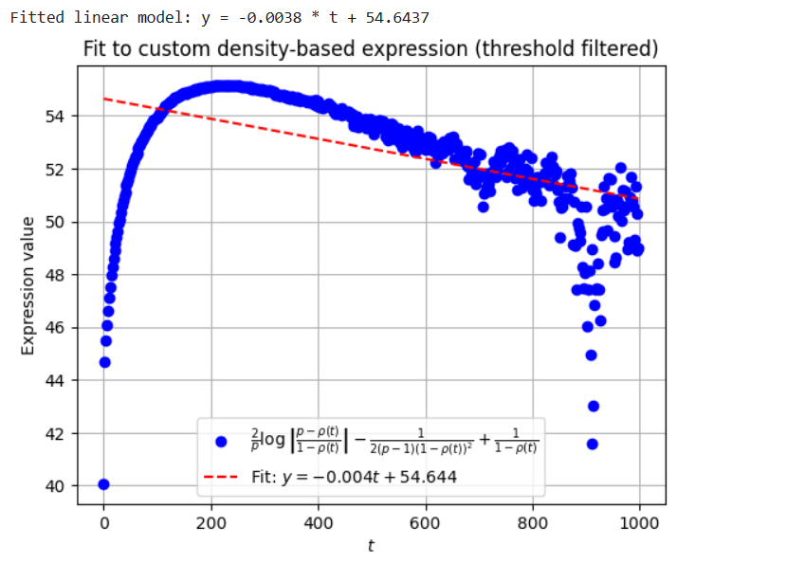

# EAST

### **P=0.5, initial = 0** “data_east_q(0.5)_ini(0)”

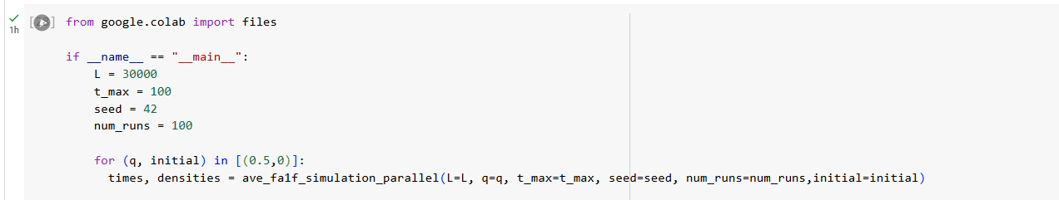 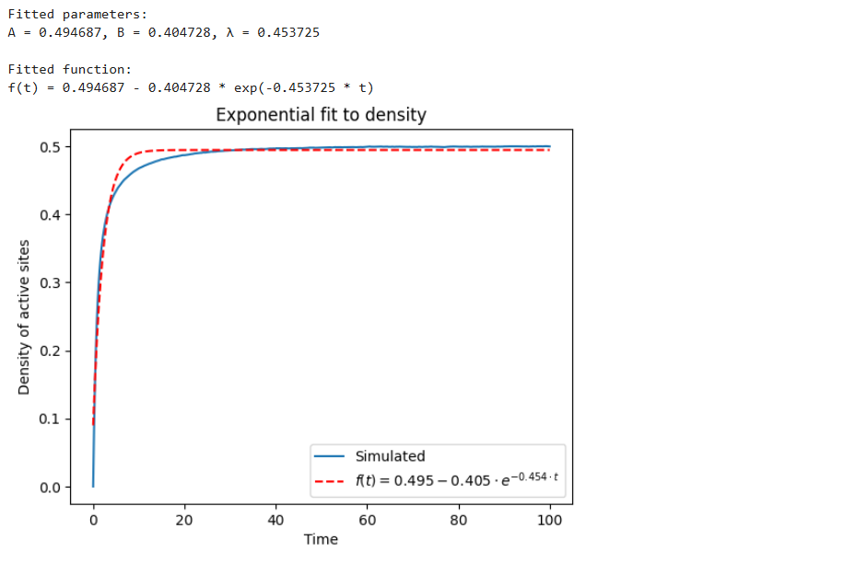

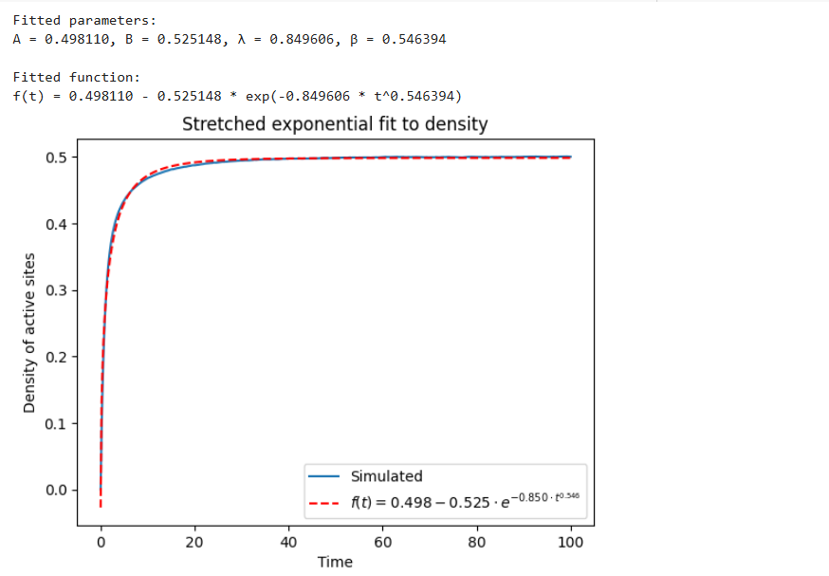 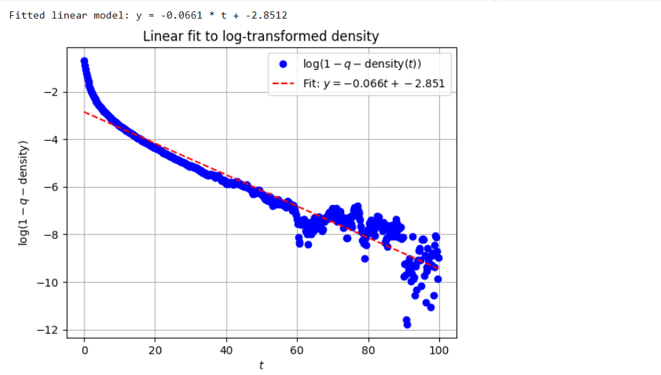 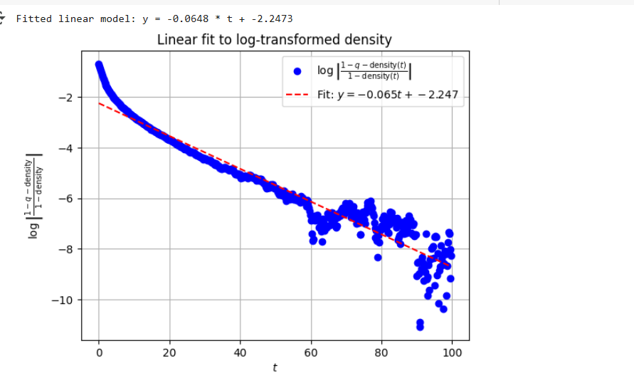

### P = 0.5, initial = 0.49 “data_east_q(0.5)_ini(0.49)”

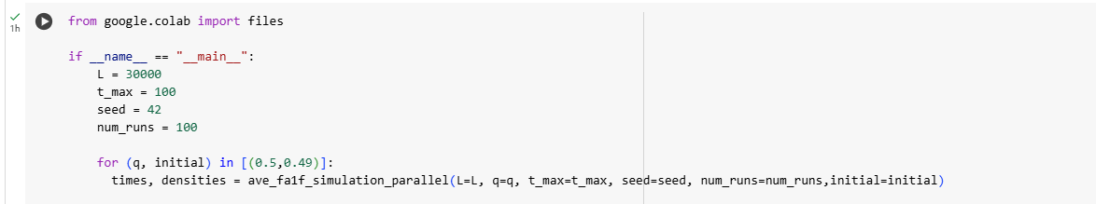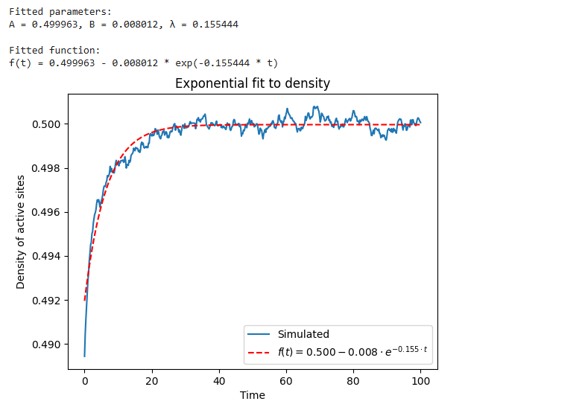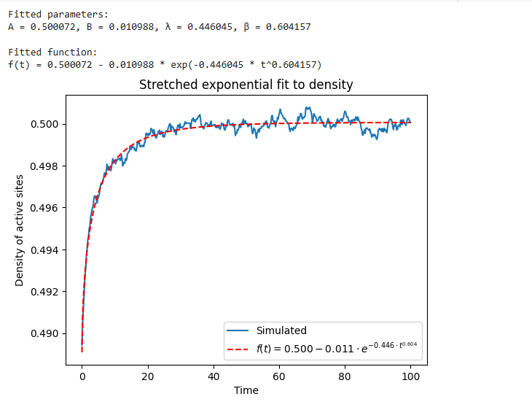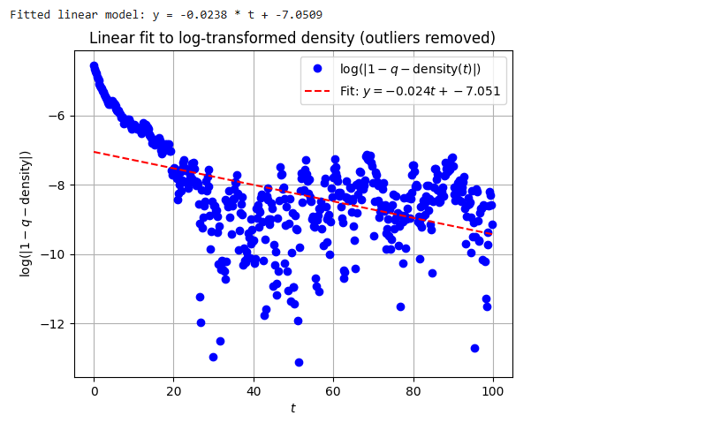

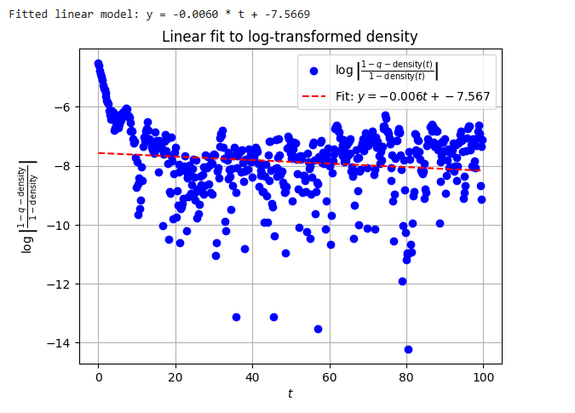

### **P=0.1, initial=0**, “data_east_q(0.9)_ini(0)”

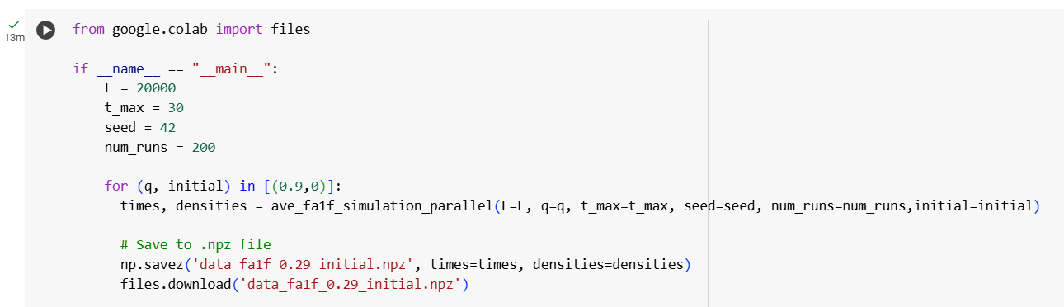

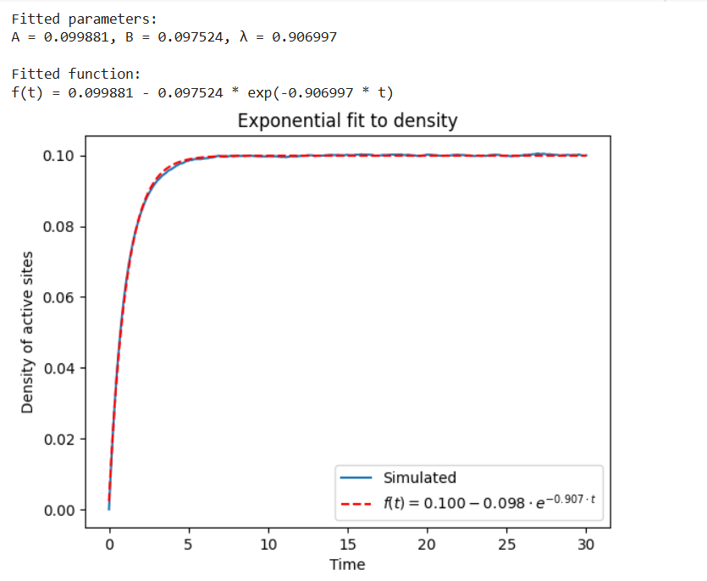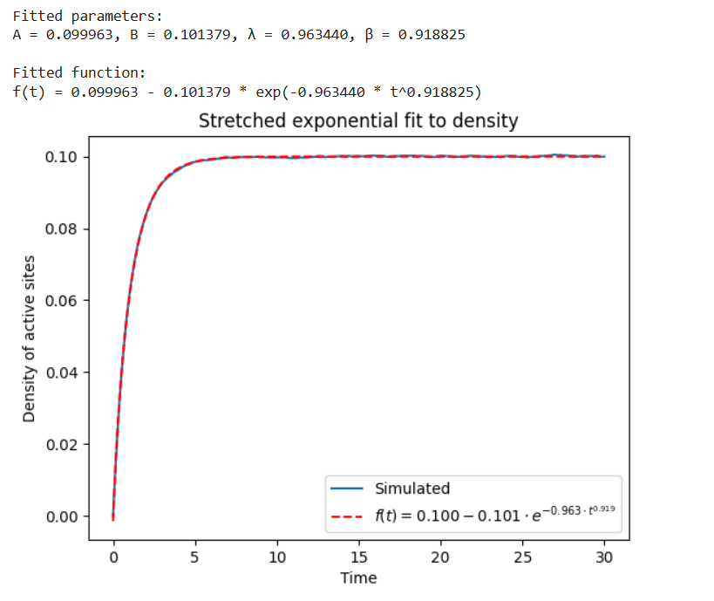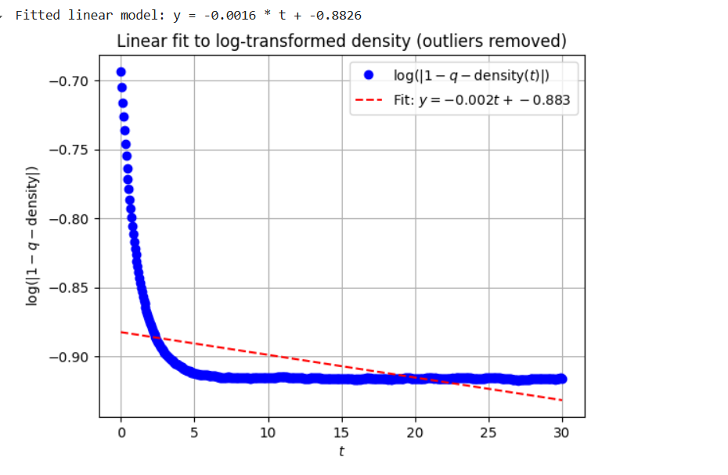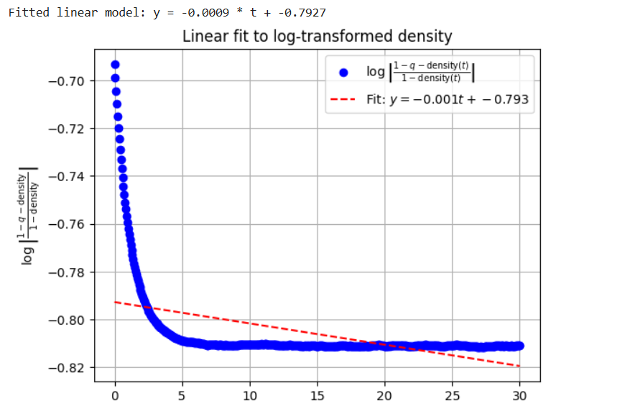

**P=0.8, initial=0**, “data_east_q(0.2)_ini(0)”

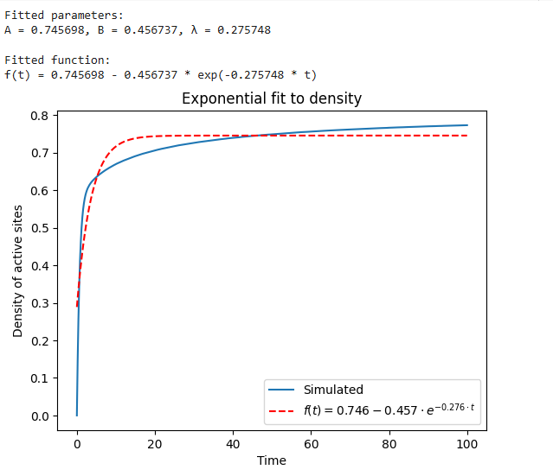

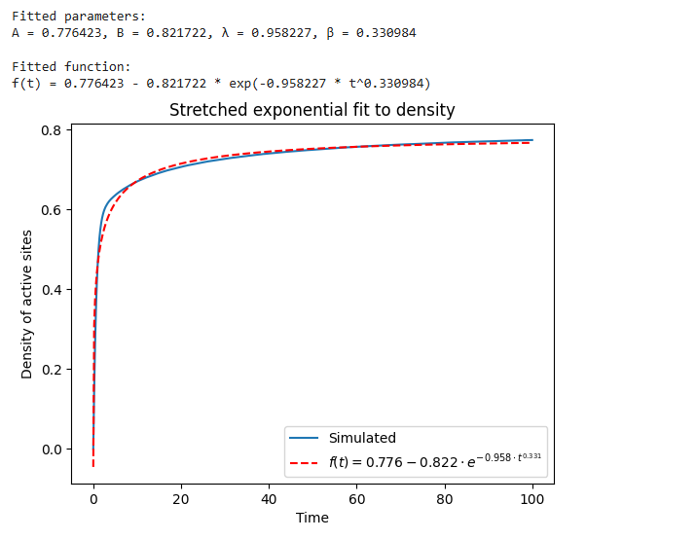

**P=0.9, initial=0**, “data_east_q(0.1)_ini(0)”

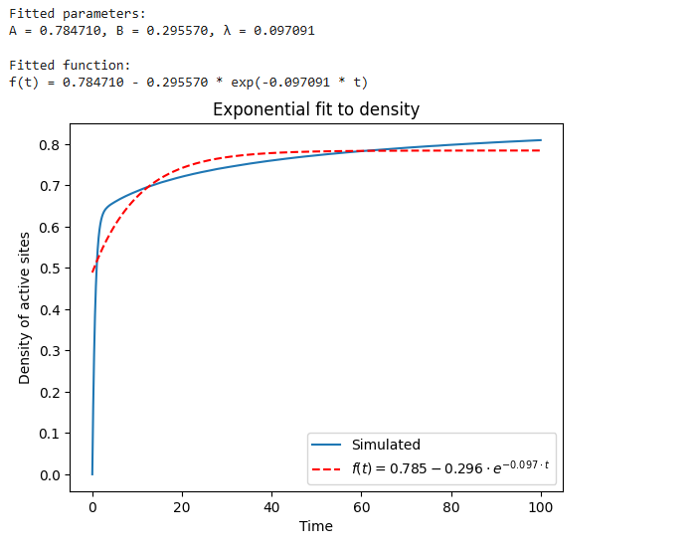 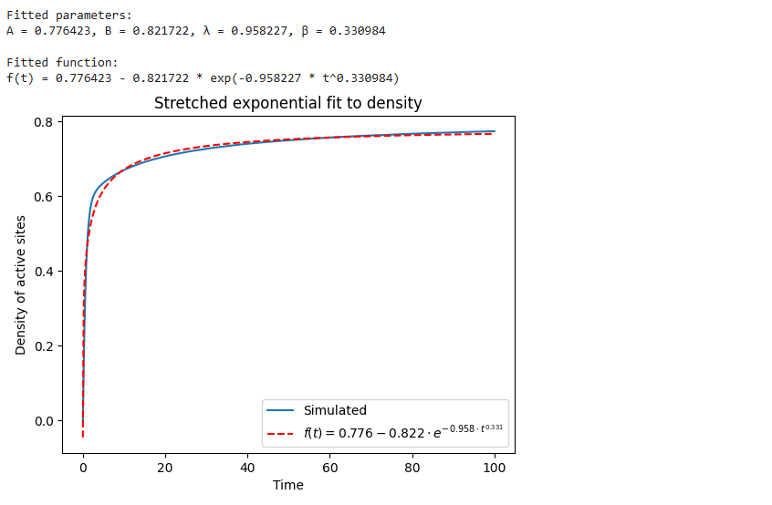

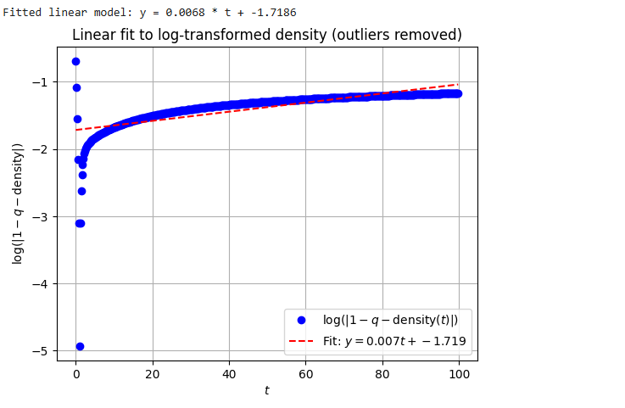

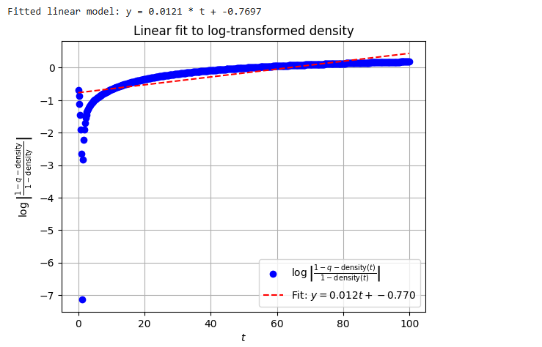

**P=0.9, initial=0.85**, “data_east_q(0.1)_ini(0.85)”



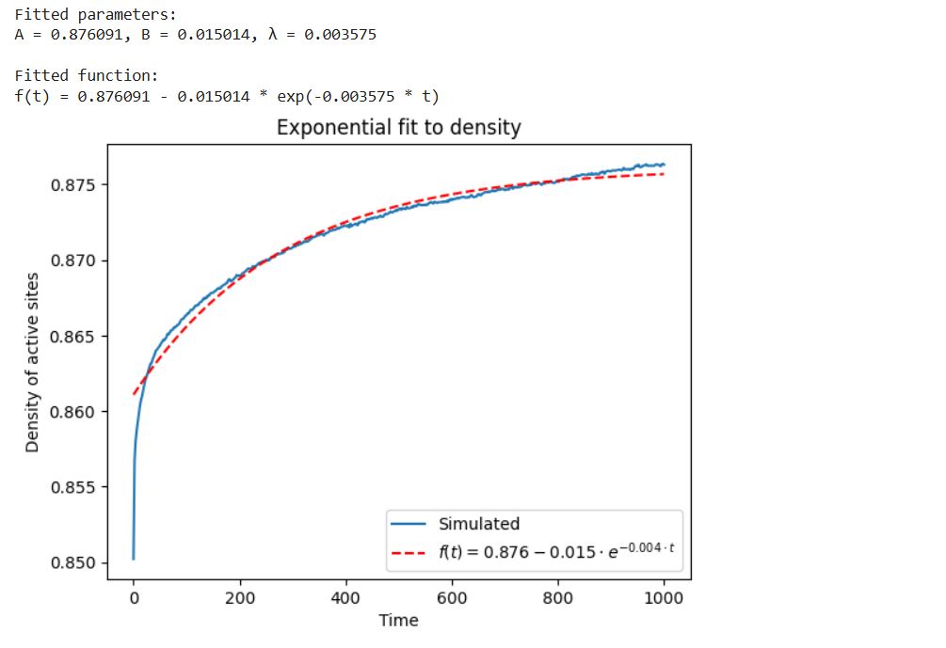 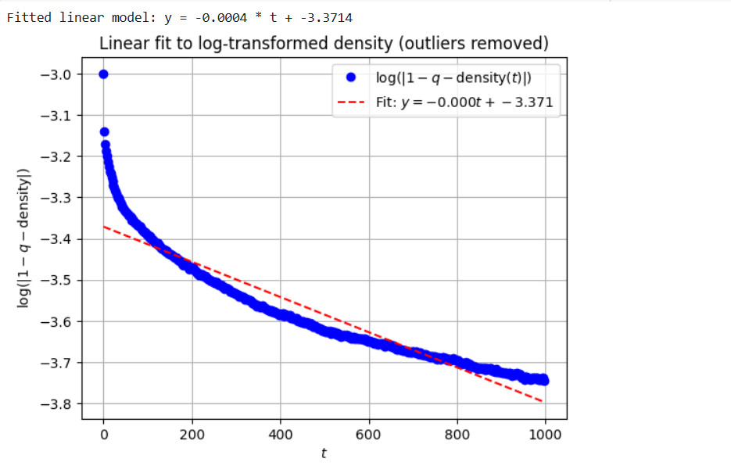 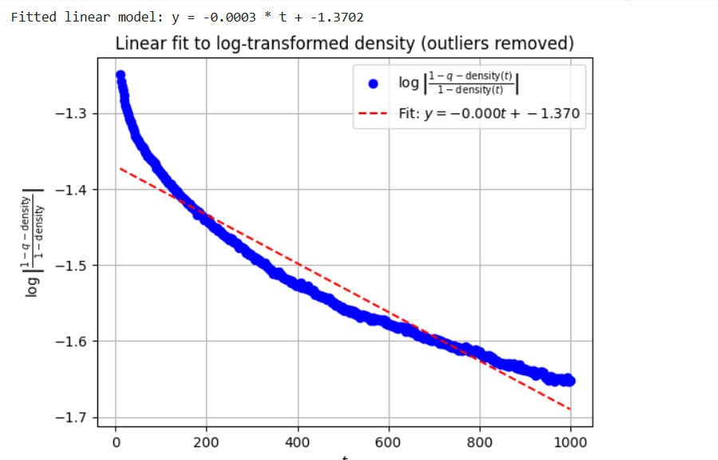

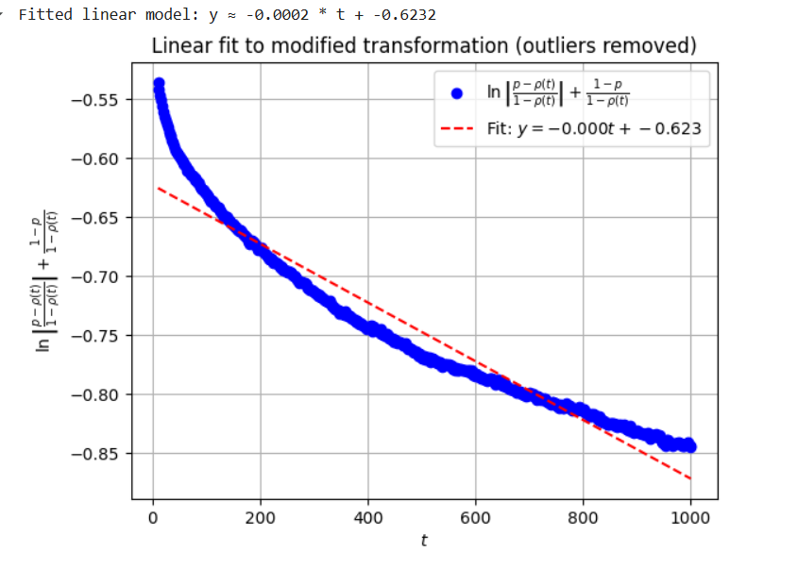 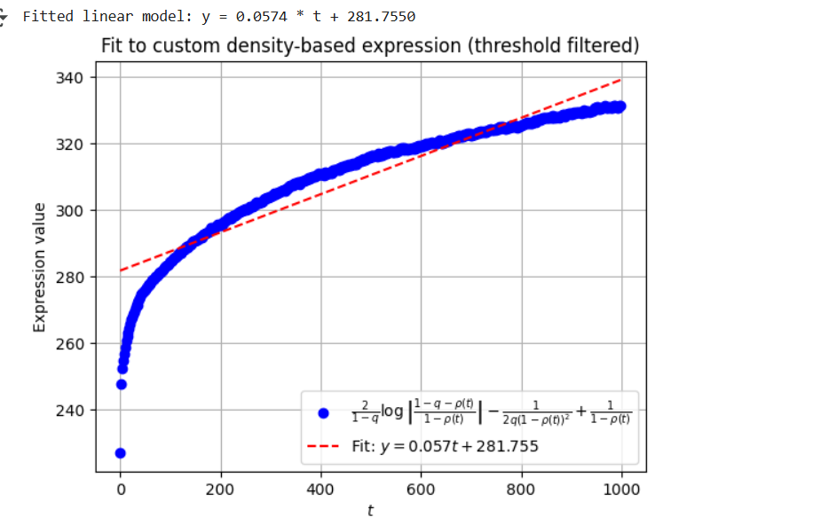

**P=0.8, initial=0.75**, “data_east_q(0.2)_ini(0.75)”



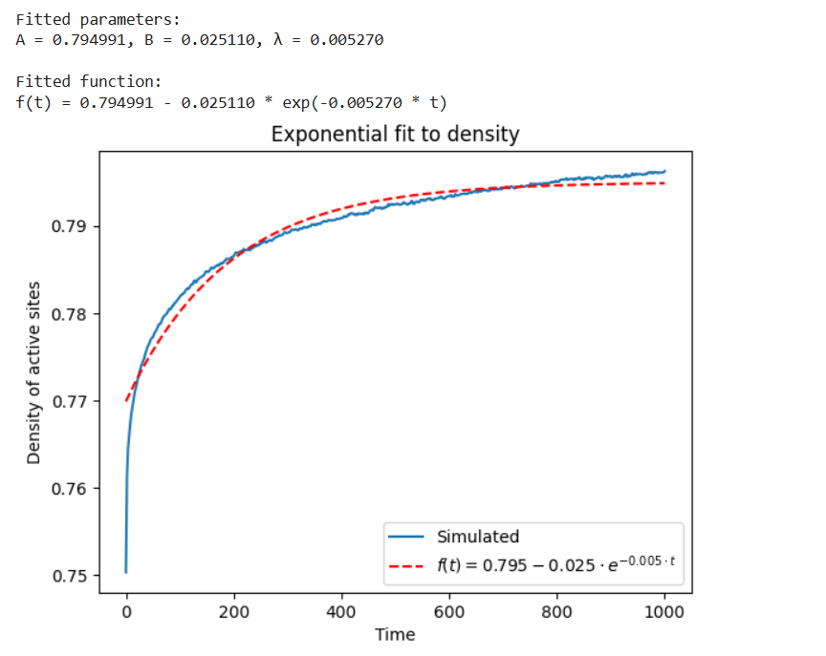

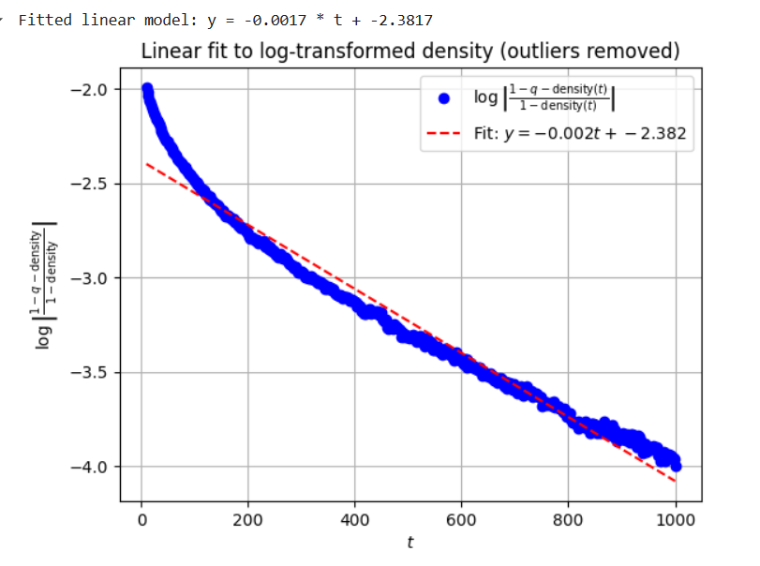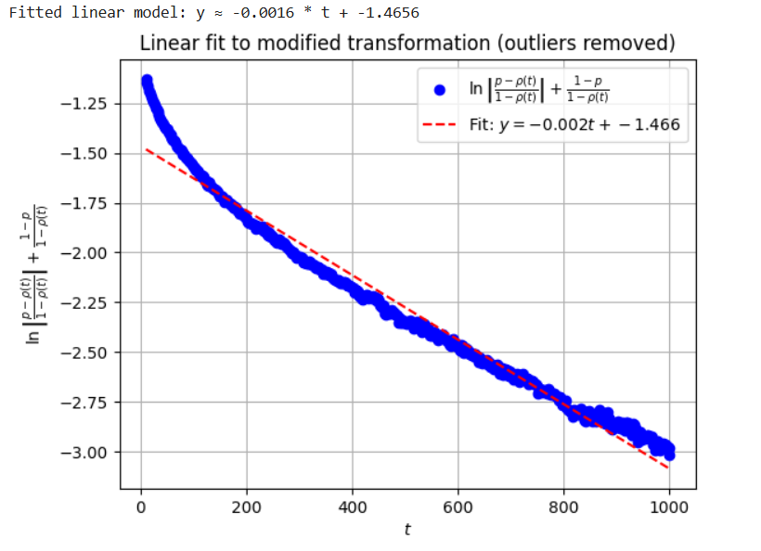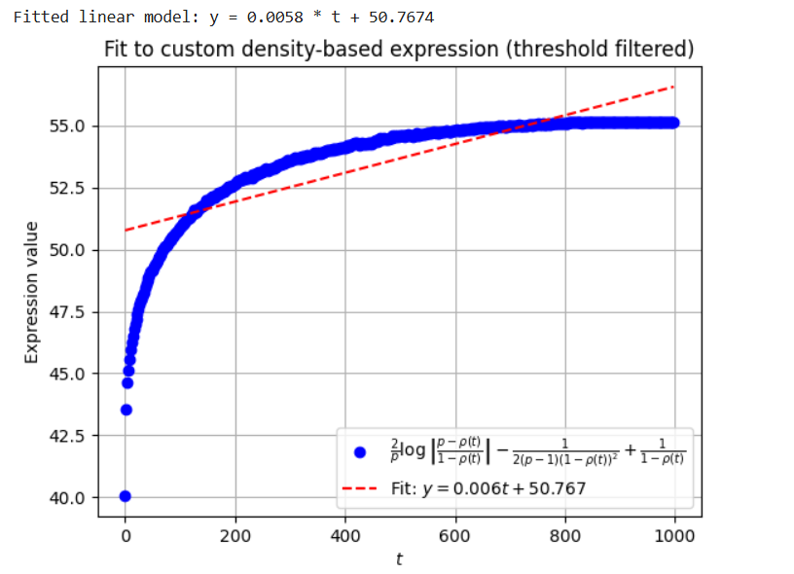

**P=0.7, initial=0.65**, “data_east_q(0.3)_ini(0.65)”



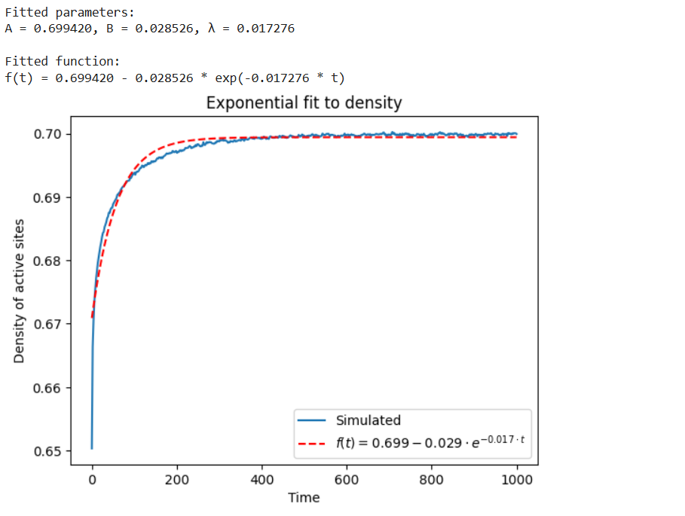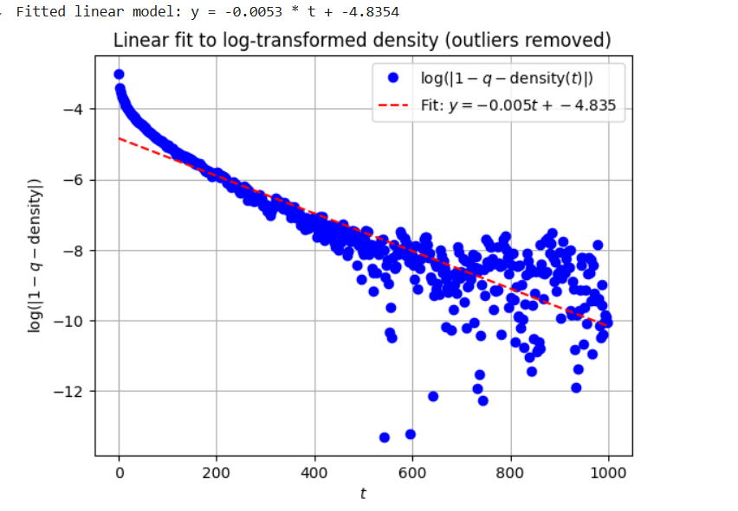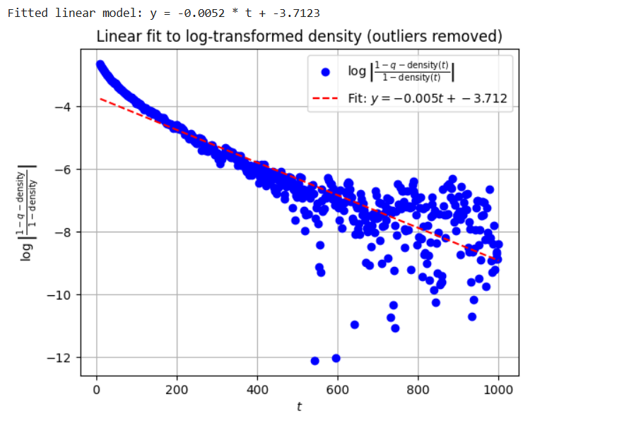

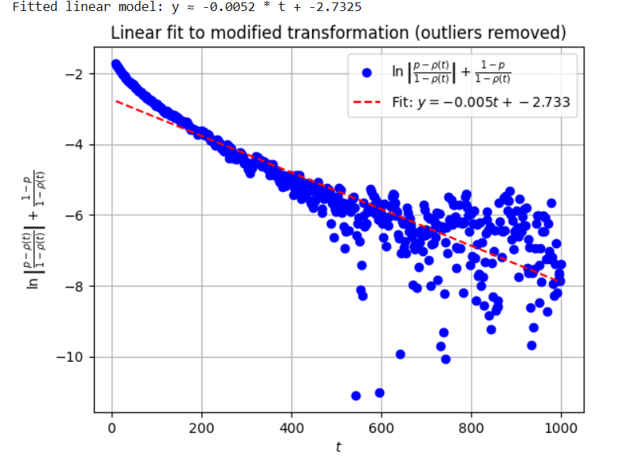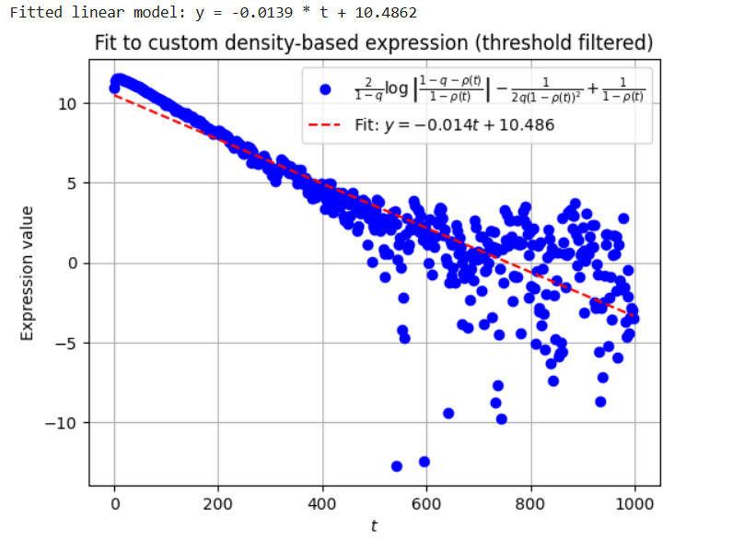

**P=0.6, initial=0.55**, “data_east_q(0.4)_ini(0.55)”



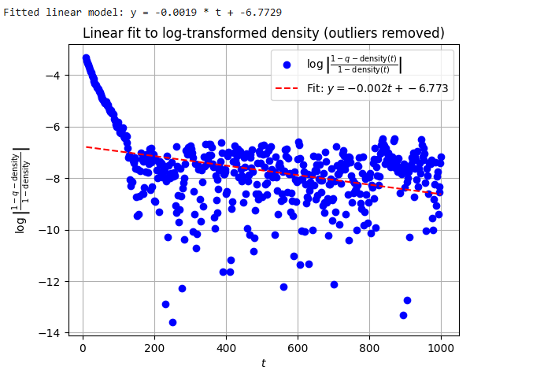

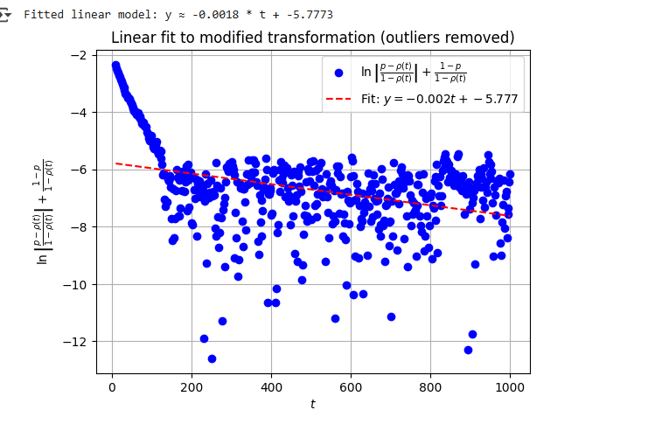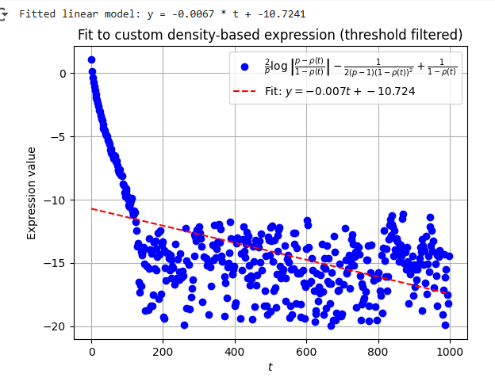

# Addictive Model

### P = 0.5, initial = 0 data_addictive_q(0.5)_ini(0)

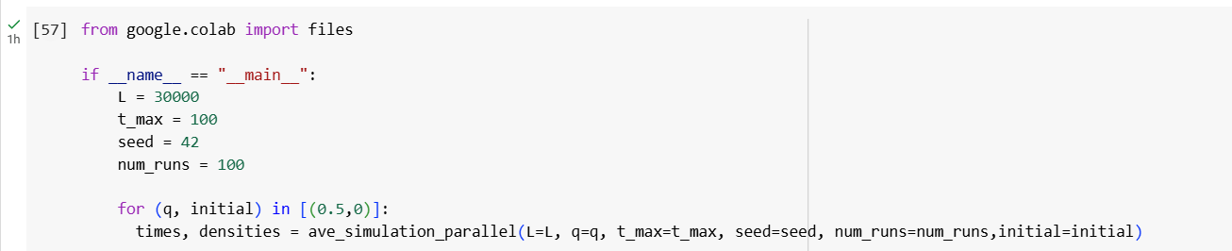

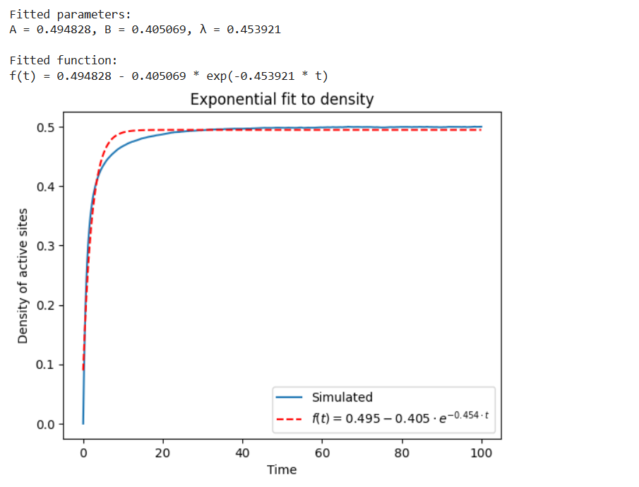 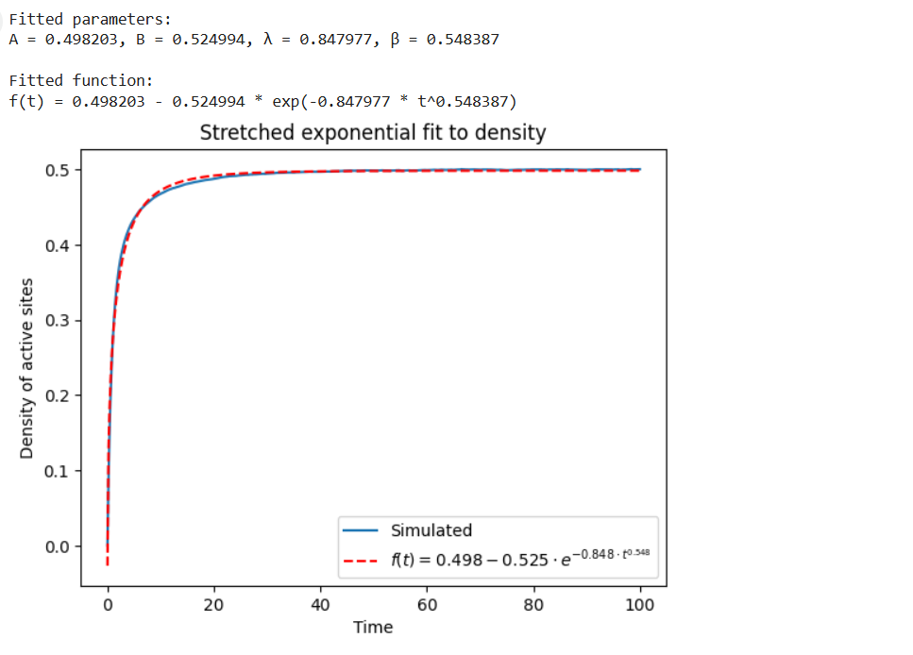 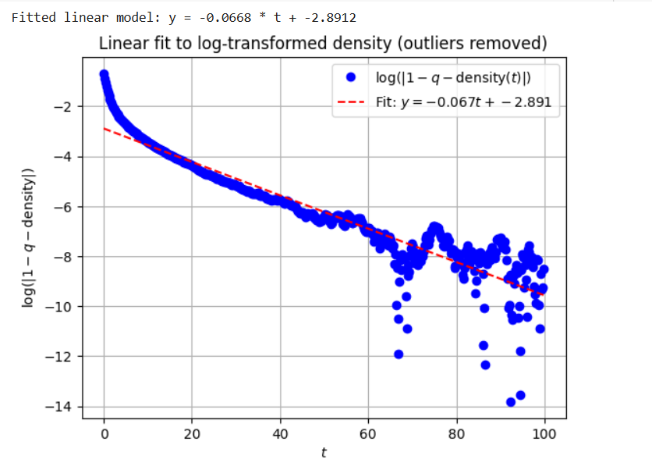 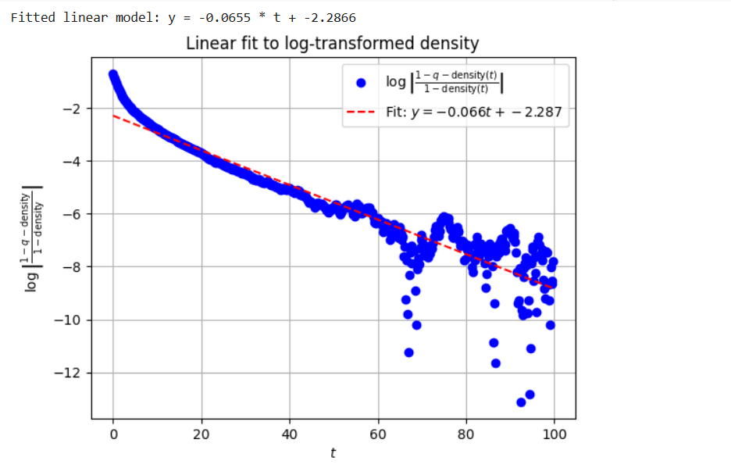

**p=0.7, initial=0.65**, “data_addictive_q(0.3)_ini(0.65)”



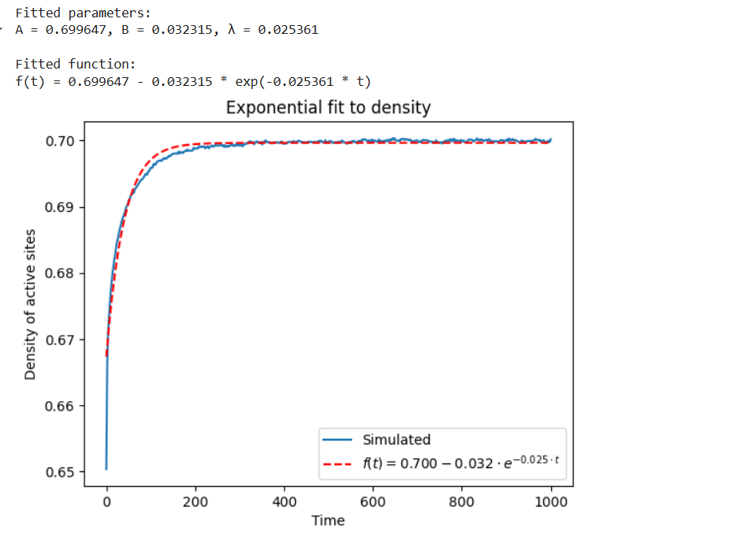

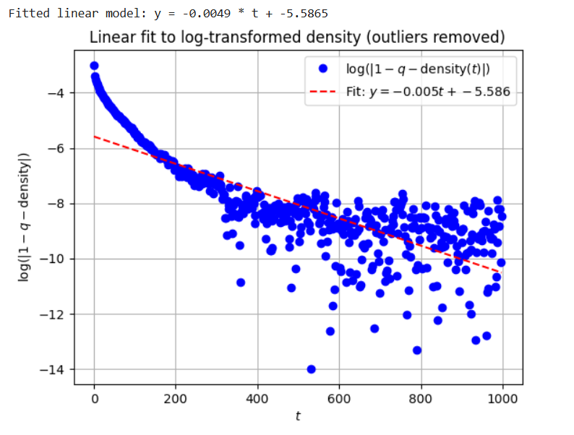

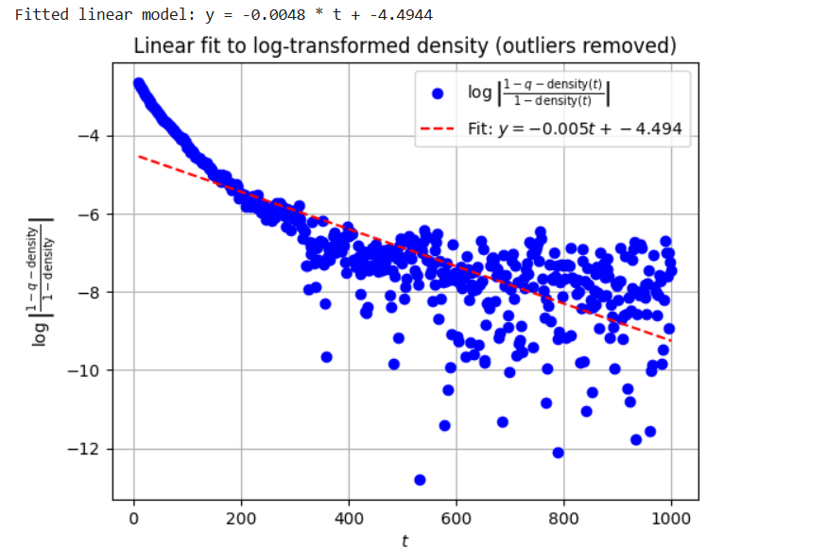

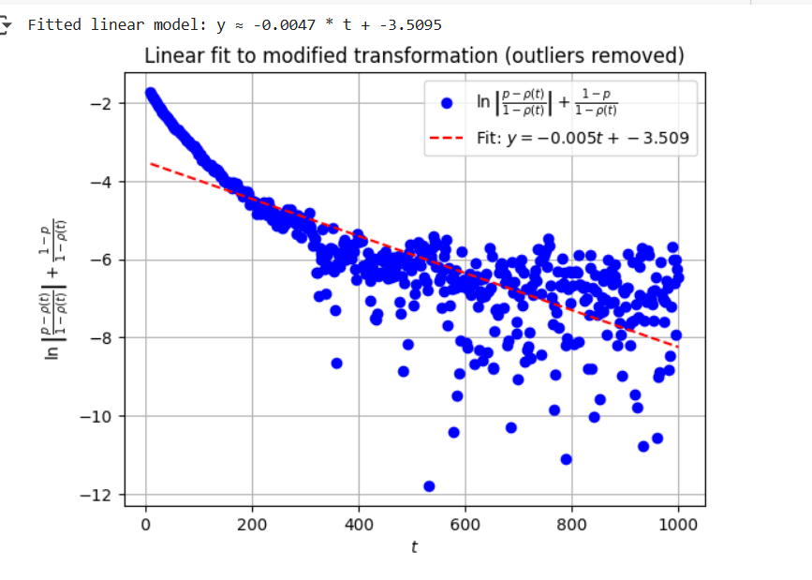

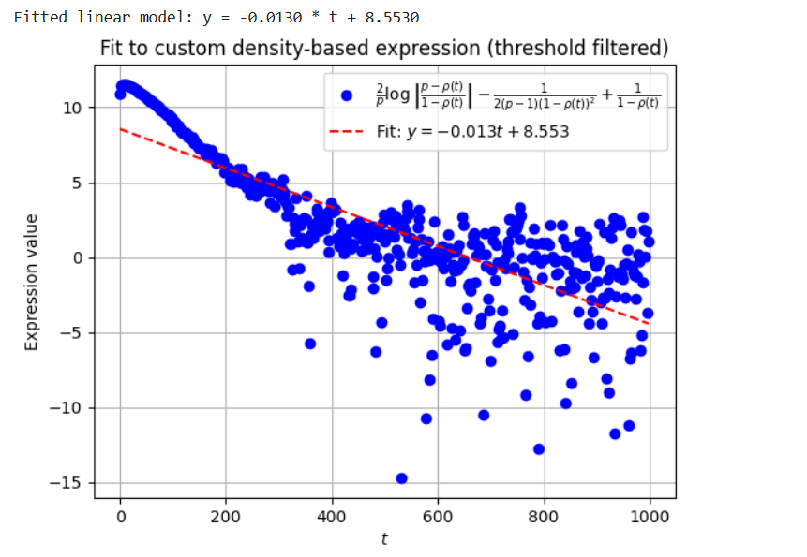

**p=0.8, initial=0.75**, “data_addictive_q(0.2)_ini(0.75)”



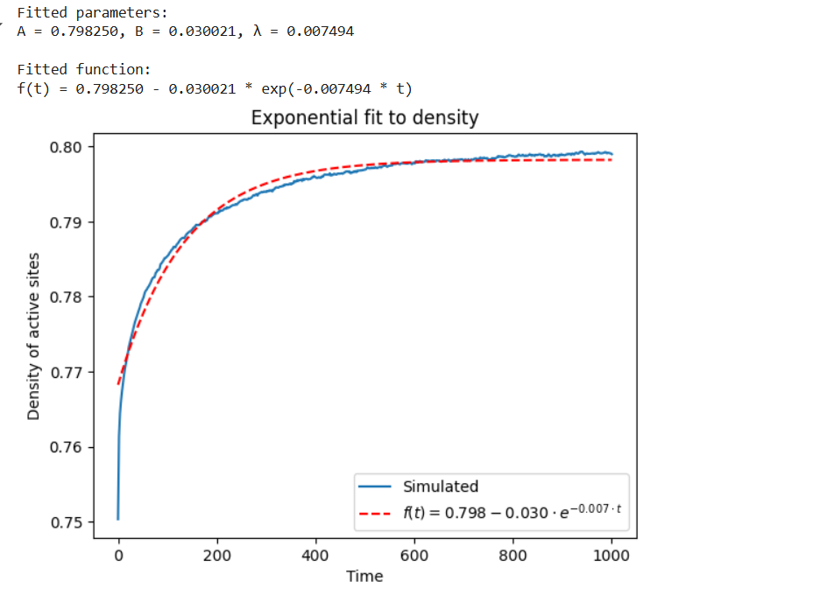

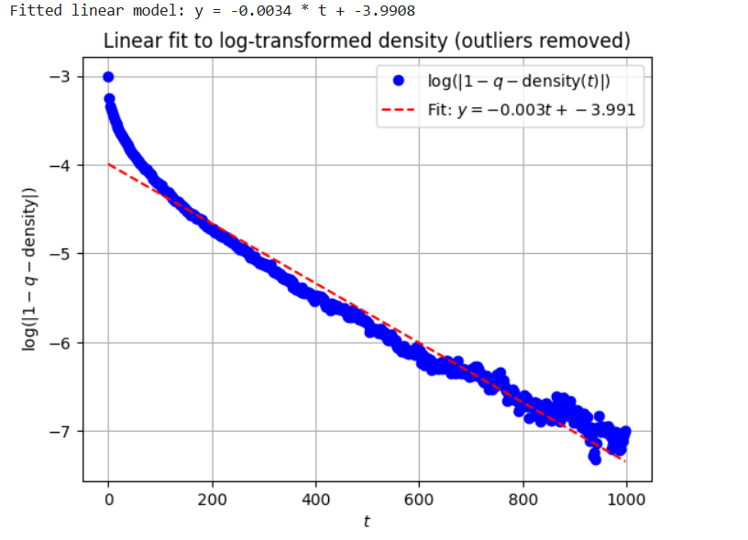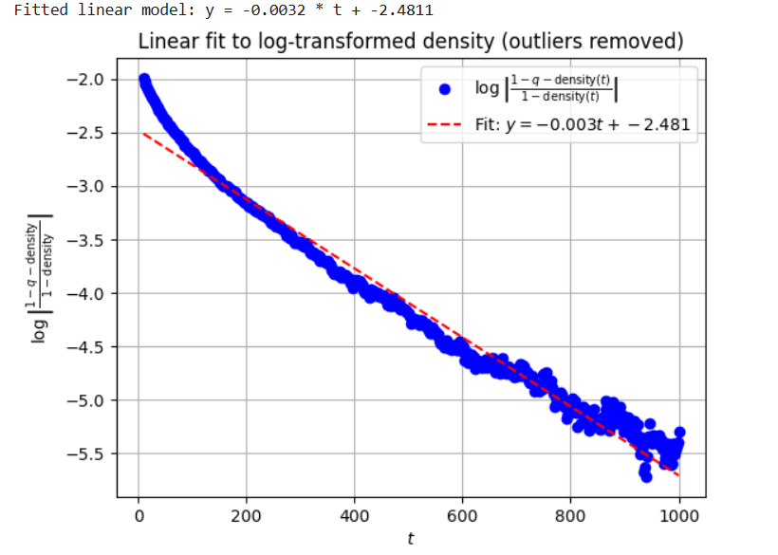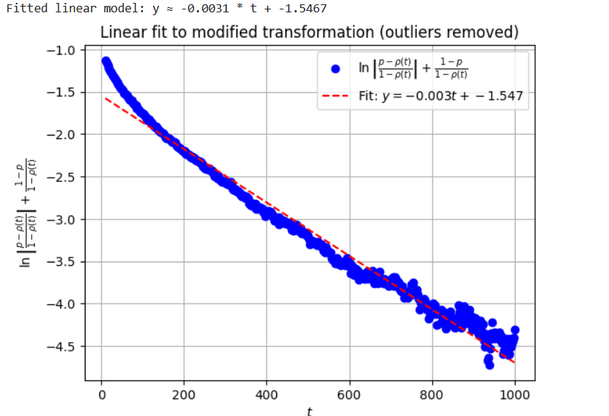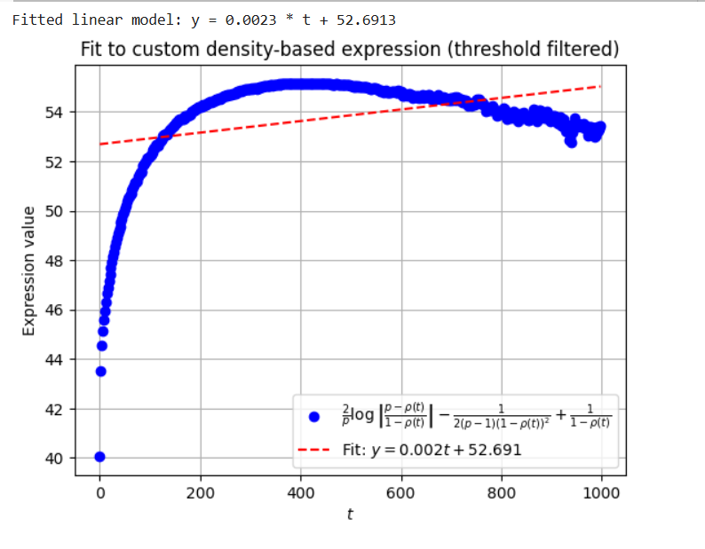

**P=0.9, initial=0.85**, “data_addictive_q(0.1)_ini(0.85)”



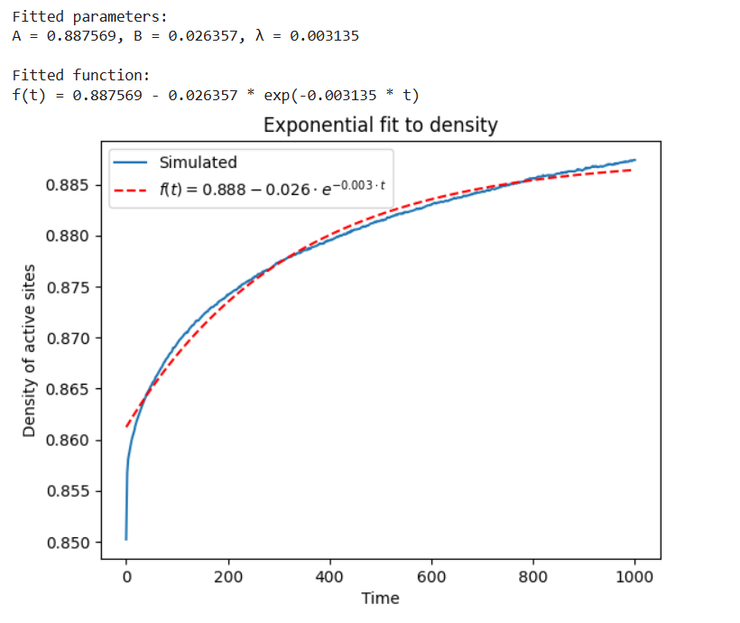 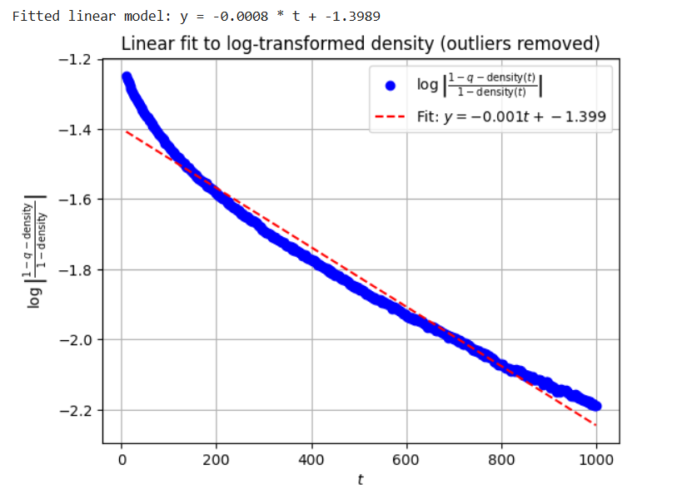 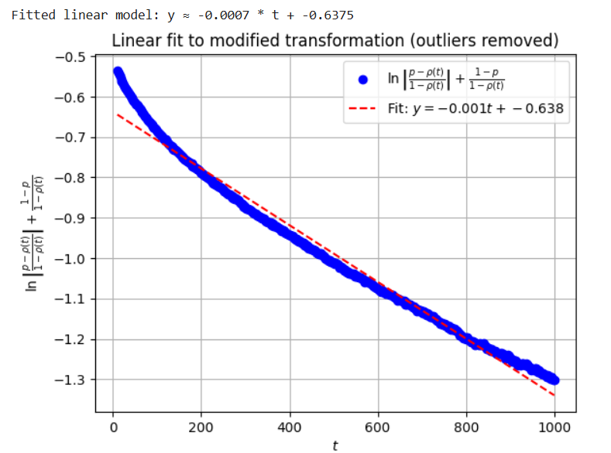 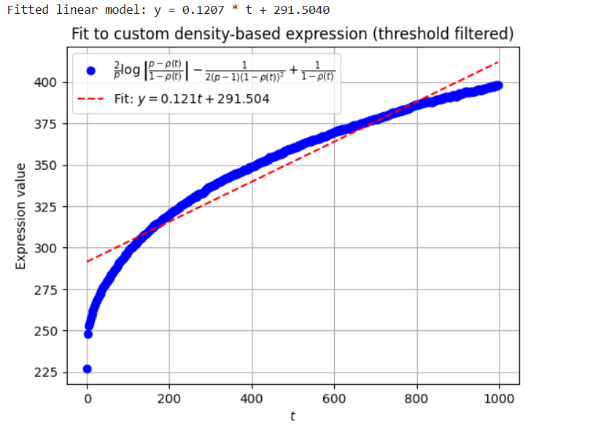

# Starting with initial density = 1

**L=5000**

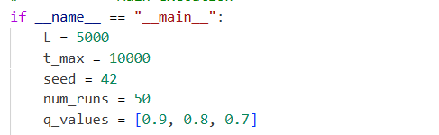

P=0.1

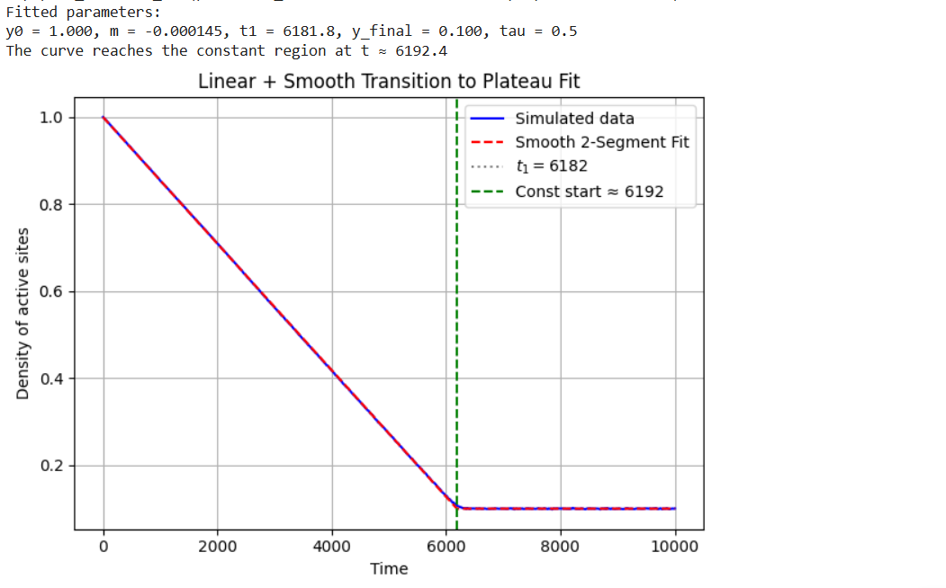

P=0.2

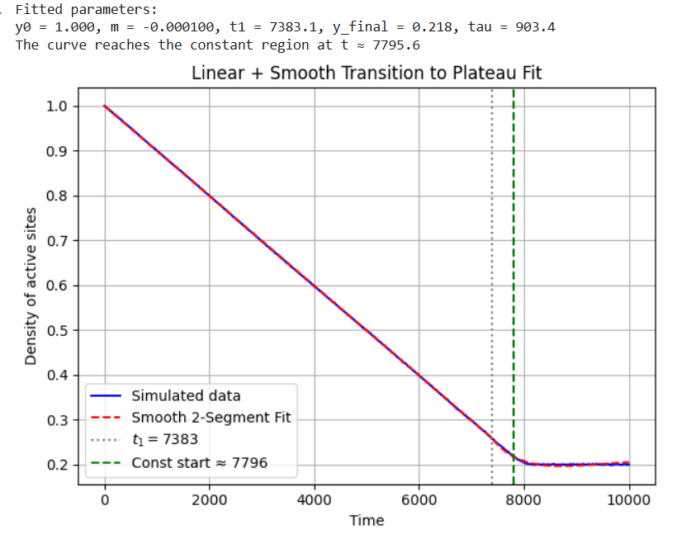

p=0.3